Introduction – Let’s imagine that we are Israelites in the wilderness experiencing many ups and downs through following Moses’ leading. The ark of covenant contained 3 physical items from God, the tablets, the manna and Aaron’s rod which allowed a tangible relationship with God.

Let’s share some moments when your faith in God was the most real for you.

Bible reading
- Read Psalm 132 again!

- What words and phrases indicate how David feels about God?
- What consuming purpose is David pursuing?
- What was the mood in the city when the ark of the covenant was finally brought to Jerusalem?
- This passage gives us a sense of David’s joy in persistently following God. What keeps you persisting in your faith?
- How did the Lord assure Israel of future blessings?

- Read Isaiah 43:18-21
Isaiah 43:18-21 “Forget the former things; do not dwell on the past. See I am doing new thing. Now it springs up: do you not perceive it? I am making a way in the desert and streams in the wasteland…The people I formed for myself that they may proclaim my praise.”

- In our life, it can be like being in the wilderness. How does the assurance of God’s faithfulness encourage you to obey and follow him?
- How will you bring those parts of your life into closer harmony with God’s promise?

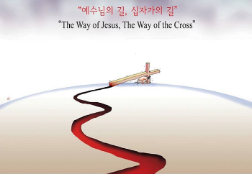 WHICH LIFE TO CHOOSE?

God’s purpose or mine? Discuss / Repent
We tend to think that if Jesus Christ compels us to do something and we are obedient to Him, He will lead us to great success?? Have you used God’s words to fulfil your particular goals like the Israelites used the ark to fight the Philistines?

What is my vision of God’s promise for me? Discuss
What to do ‘now’? His purpose is for me to depend on Him and on His power now. If I can stay calm, faithful, and unconfused while in the middle of troubles, the goal of the purpose of God is being achieved in me.

Praise and prayer
Let’s praise Jesus by listening the song ‘Still’ - Hillsong United with Lyrics, (YouTube)
- Pray for each other and encourage each other passionately!!!
- Pray for Ukraine as there are many our brothers and sisters are suffering!
By faith, we can Remember ‘1 (me) +1 (you) = 1 (One body in Christ)’
- Pray for the people whose obedience serves as a living example for you.
(Church leaders, Deacons, Worship Musicians, Teachers, Helpers, Missionaries….so many!!)

