NMBC July 16, 2023 Jesus story of the wise and foolish builders
Two metaphors of spiritual growth
Colossians 2:6,7 “… rooted and built up in Him ..”
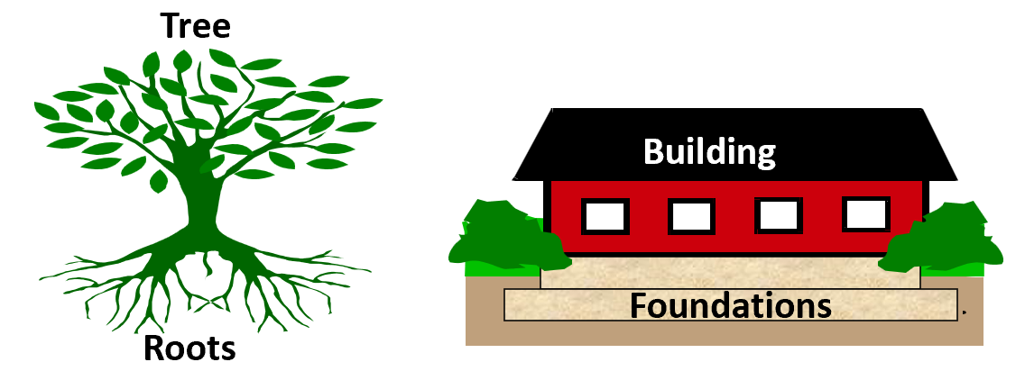
Compare Psalm 1:1-3; Jeremiah 17:7,8; 1 Corinthians 3:5-15; Matthew 7:24-27.
Read and Reflect on Matthew 7: 24-27 and Luke 6:46-49
The Gospels give us two accounts of Jesus telling this story one in Matthew’s Gospel and on a different occasion in Luke. It seems likely that this was a story that Jesus often told to highlight the importance of paying close attention to His teaching and making sure we put it into practice in our lives.
Two things that are the same for both builders:
Both are building a house
  - The building of our lives, character, reputation, career, family life, education, relationships. Every day we make choices—what plan do we build by? Who is the architect of our house?
  - When people build houses to live in they pay careful attention to how it is built because it is a major investment, but how much more important is it to pay attention to how we build our lives! Yet many of us are careless about how we build our lives, making choices day by day based on how we feel, without thinking about the long-term consequences.
Both experience the rain, the wind and the flood (verses 25 and 27)
  - Floods and storms come to both:
  - A popular misunderstanding about following Jesus that only good things happen if we try to follow His teaching. But the flood and storms in Jesus’ story come to both builders
  - Life brings ‘storms and floods to everybody’. Life is more difficult than I expected it was going to be!
  - What tests the house: tests and difficulties of life James 1:2-4, temptations to sin 1Corinthians 10:13,
  - Ultimately the final great test when we stand to give account of our stewardship 1 Corinthians 4:1-4.

Two things that are different for the two builders:
One built his house on rock:
Jesus says of this person: they come to Jesus, hear His word and put it into practice
Jesus also says that they “dug down deep and laid the foundation on rock”
Digging has in it the idea of removing and clearing away the sand, the material that is not stable or suitable foundation material.
- In Colossians 2:6-8 Paul warns of basing our lives on “philosophy, empty deceit, human tradition and the basic principles of the world and not on Christ” But it is these things that the great majority on people around us are basing their lives on. But Jesus said in John 8:31,32 If you continue in my word you are truly my disciples and you will know the truth and the truth will set you free.
One built his house on sand:
- I imagine that the man building his house on the sand thought that it was a foolish waste of time and effort to ‘dig down deep’
- He wasn’t prepared to put in the effort. He was gambling with the future of his life.
The house on the rock did not fall:
- None of us knows what the future holds and when the storms of life may come to test us but we can know now whether our lives will stand the test because we can know now that we are building our lives on rock!
The house on the sand fell with a great crash.
- Luke “It collapsed and its destruction was complete”
- What a sobering end to the story. But how important to take this to heart.
Apply: Wise or foolish? Which are you?
Start Digging!
  - Mark’s Gospel (then Luke/Acts and John)
  - www.youversion.com (Bible App)
Dig Deeper!
  - Choose a book of the Bible each month
  - www.precept.org.uk (Bible studies online)
Make sure you apply what you learn.
What I think/believe or How I behave?

