**Sunday 25th November**

**Talk Summary and Small Group Questions**

**Acts 4 32 -37 The believers share their possessions**

**Introduction** - recent messages focus on giving Acts 22 v 44/45, Malachi 3 v 10 and Acts 4 32-37

Giving is not just about money, its sharing possessions , time and encouraging each othger with a generous spirit

Warnings about relying on possessions – Matthew 6 v 24, 1 Tim 6 v 6-10

**Right Giving based on three things:**

Gratitude – Acts 4 v 32, Acts 2 v 40 and 2 Cor 8 v 2

Glasses – look around at what is happening – the privilege of partnership in the gospel 2 Cor 8 v 4

Generosity – 2 Cor 9 v 6-14

Generosity Quotations “ the habit of giving freely without expecting anything in return”

“ we make a living by what we get, but we make a life by what we give”

“Our generosity is measured not by what we give but by what we keep”

Lets pray for generosity!

**The grace of giving – 2 Cor 8 v 7** - what a measure to strive for…

Thankfully God is involved:

God enables us :

2 Cor 8 v 1, 2 Cor 9 v 14, 2 Cor 8 v 9,

God multiplies and provides acts 4 v 33 , 34

God’s grace was so powerfully at work in them that there was no needy person among them.

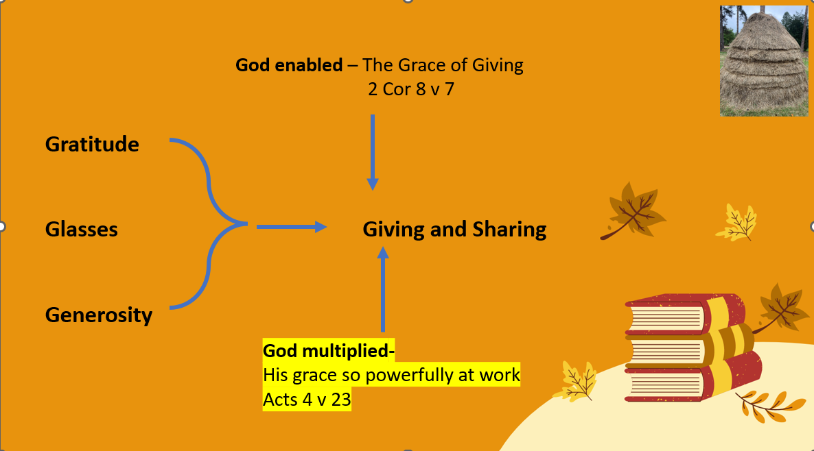

**Questions**

Acts 4 v 32-36 is headed the believer share their possessions – what role is God playing? Verses32/33 = check out different versions and look out for the phrase God’s grace was so powerfully at work.

How is the believers’ gratitude to God expressed? Acts 2 v 46/47, Acts 4 v 32, 2 Cor 8 v 2 2 Cor 8 v 4

When NMBC makes appeals for money, how do we avoid making people feel uncomfortable or guilty and does it matter if we do?

The believers pleaded with Paul for the privilege of sharing in the gospel 2 Cor 8 v 4 How might we better encourage follks to be interested in our local and international ministries. Do consider taking a small group visit to MMCC or invite Jung to a future meeting to talk about her work and her trip with Open Doors.

Read 2 Cor 8 v 6 – How would you define generosity? – discuss the quotations on the summary page. There are other quotations and images on the web

2 Cor 8 v 10 -20 The Message translation says ‘The heart regulates the hands’ What does that mean?

Paul encourages the Macedonians to excel in the grace of giving? What are the characteristics of grace. Why do you think Paul refers to giving as a grace?

How as God involved in helping the Macedonians 2 Cor 8 v 1, 9 v 14

Can you share examples where God has encouraged you to be generous?

What other practical ways can we share possessions/time/talents - give thanks for everything that is happening.

What was the result of God’s grace in the early church – Acts 4 v 34

Read 2 Corinthians 9 v 8 -11 – takes note of God’s promises and pary for God’s grace to bound around among us

Pray that God would enable our giving and multiply its effect to bring thankfulness to him.